1. If the sender’s CDMA code is : (1, −1, 1, −1, 1, −1, 1, −1)
   1. (‐1, 1, ‐1, 1, ‐1, 1, ‐1, 1, 1, ‐1, 1, ‐1, 1, ‐1, 1, ‐1)

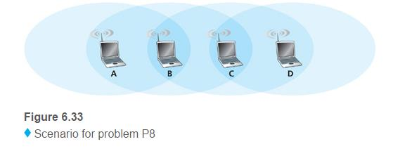

* 1. A: 1 message for every 4 slots, B: 1 message for every 2 slots, C: 1 message per 1 slot, D: 2 messages each slot
  2. 1 message every slot. They’re only going one direction.
  3. Same, 1 message per every slot. It’s still only going one direction
  4. A: 1 message for every 4, B: 1 message for every 2, C: 1 message per 1 slot, D: 2 messages each slot